

**FACULTY OF ENGINEERING AND TECHNOLOGY**

**COURSE UNIT: COMPUTER PROGRAMMING**

**REPORT ABOUT THE MATLAB ASSIGNMENT**

**SUBMITTED BY: GROUP 2**

**GITHUB LINK:** **https://github.com/matlab-group-2/group-2-matlab**

**Lecturer: ENG. BENEDICTO MASERUKA**

**Date of submission: ........../............./...................**

## **DECLARATION**

We hereby certify and confirm that the information in this report is out of our own efforts,

research and it has never been submitted in any other institution for any academic purposes.

|  |  |  |  |  |
| --- | --- | --- | --- | --- |
| **STUDENT NAME** | **COURSE** | **REGISTRATION NUMBER** | **GITHUB LINK** | **SIGNATURE** |
| Chelimo Sandra | WAR | BU/UP/2024/5402 | https://github.com/chelimosandra6-png/Chelimo-Sandra-.git |  |
| Nakazibwe Ethel | AMI | BU/UP/2024/0835 | https://github.com/ethelnakazibwe9/Nakazibwe-Ethel-.git |  |
| Poffia Adongo | AMI | BU/UP/2024/0823 | https://github.com/padongo240823-ops/Poffia2004#:~:text=https%3A//github.com/padongo240823%2Dops/Poffia%2D2004.git |  |
| Ogutu Daniel Wafula | WAR | BU/UP/2024/1060 | https://github.com/ogutudanielwafula-collab/ogutu-daniel-wafula |  |
| Owor Hamidu | PTI | BU/UP/2024/2600 | https://github.com/hamiduowor/hamiduowor.git |  |
| Muhangi Mouris Mathew | MEB | BU/UP/2024/5345 | https://github.com/mourismuhangi-prog/Muhangi-Mouris-Mathew-#:~:text=https%3A//github.-,com,-  /mourismuhangi%2Dprog/Muhangi |  |
| Odongo Joseph Aryong | AMI | BU/UP/2024/0840 | https://github.com/odongjoseph12/joseph.git |  |
| Obur Charles | APE | BU/UP/2024/3743 | https://github.com/charlesobur86/Obur-Charles-.git |  |
| Onanyang Francis | WAR | BU/UP/2024/4757 | https://github.com/onanyangfrancis800-ux/ONANYANG-FRANCIS-.git |  |
| Econi Ronald | AMI | BU/UG/2024/5092 | https://github.com/econironald543-design/ECONI-RONALD-.git |  |

## **APPROVAL**

This is to confirm that this report has been written and presented by Group 2, giving the details of the MATLAB assignment and what they learnt.

**LECTURER;**

**NAME:** .............................................................................................................

**SIGNATURE:** ......................................................................................................

**DATE:** ....................................................................................................

## **ABSTRACT**

We started our assignment in the Busitema University library out of which were we exposed to various codes in the different sections through Group 2 members, we generated the codes necessary from the work that we were taught in the lecture and also researched

on more information that could help us complete the assignment.

## **ACKNOWLEDGEMENT**

We would like to thank the Almighty God for giving us the strength to carry on with our assignment as Group 2. We would love to extend our gratitude to all the people with whose help we managed to make it. The willingness of each one of us to put in the time and provide constructive feedback has been immensely valuable in this assignment. Lastly, we would like to express our gratitude to all the sources and references that were used.

## **DEDICATION**

We dedicate this report to all the students of Group 2, who have been there for us in the process of formulating and producing this report. We also dedicate this report to our lecturer Mr. Benedicto Maseruka whose guidance and expertise have been invaluable, his mentorship

and insightful feedback have shaped our understanding.

Table of Contents

**DECLARATION** ii

**APPROVAL** iii

**ABSTRACT** iv

**ACKNOWLEDGEMENT** v

**DEDICATION** vi

**CHAPTER ONE** 1

**ASSIGNMENT ONE PART (A)** 1

**Reading table into MATLAB** 1

**Tables for each year (Data Segmentation by Year)** 1

**Convert table to structural arrays** 1

**Convert structural arrays to tables** 2

**Write tables in excel** 2

**ASSIGNMENT ONE PART (B)** 3

**DESIGNING TO STRUCT** 3

**ASSIGNING VALUES** 3

BELOW IS THE ENTIRE CODE 4

**CHAPTER TWO** 6

**ASSIGNMENT TWO PART(A)** 6

**VISUALIZATION** 10

**BAR CHAT FOR TOTAL CAR CRASHES** 10

ASSIGNMENT TWO PART (B) 23

EXTRUCT INTO ARRAYS 23

THE ENTIRE CODE 24

**BAR CHAT OF TRIBES** 28

**RELIGION DISTRIBUTION** 28

**HISTOGRAM OF AGES** 30

**CROSS-ANALYSIS: AGE BY RELIGION** 30

**CROSS-ANALYSIS: AGE BY COURSE** 31

**BAR CHAT OF VILLAGES** 32

**CONCLUSION AND LEARNING EXPERIENCE** 33

# **CHAPTER ONE**

## **ASSIGNMENT ONE PART (A)**

We retrieved a unique file (Nigerian_Road_Traffic_Crashes _2020_2024.csv) from a site called Kaggle.com on the web. We were able to represent data of each year through the following ways;

* Each year was represented on different tables.
* The tables were then converted to structural arrays.
* The structural arrays were then converted to tables.
* The tables were saved on a single excel workbook with each year’s table on different worksheets having appropriate sheet names.
* Using the data from the different tables, we were able to obtain different graphs to represent the information and we saved the graphs as images as required in the assignment.

The code that we used is as follows;

**Reading table into MATLAB**

* We used readtable function to import data from our file named Nigerian Road Traffic Crashes 2020 to 2024 into a MATLAB named T.
* Range = ‘’A1:K519’’ indicates that the data to be read is allocated within cells A1 to K519 of the csv file.
* ReadRowNames = true; suggests that the first column of the specified range contains row names for table.

T = readtable("Nigerian_Road_Traffic_Crashes_2020_2024.csv",Range="A1:K519",ReadRowNames=true);

**Tables for each year (Data Segmentation by Year)**

* The code then segments the main table T into five separate tables, each representing a specific year from 2020 to 2024.
* For example, T2020=T(1 : 37, : ); extracts rows1 to 37 (inclusive) from T to create a new T2020 for the year 2020.This process is repeated for T2021, T2022, T2023, T2024

T2020=T(1:37,:);

T2021=T(38:185,:);

T2022=T(186:333,:);

T2023=T(334:481,:);

T2024=T(482:518,:);

**Convert table to structural arrays**

* Finally, each of the yearly tables (T2020 through T2020) is converted into a structural array using the table2struct function.
* For instance, A = table2struct(T2020,’’ToScalar’’ , false); converts the T2020 table into a structural array as A..
* The scalar ‘’ToScalar’’ , false argument ensures that if a table contains only one row, it is still represented as a non-scalar structure array, which is useful for consistent data handling when processing multiple years. .This conversion creates structural arrays A, B, C, D, and E.

A=table2struct(T2020,"ToScalar",false);

B=table2struct(T2021,"ToScalar",false);

C=table2struct(T2022,"ToScalar",false);

D=table2struct(T2023,"ToScalar",false);

E=table2struct(T2024,"ToScalar",false);

**Convert structural arrays to tables**

* This function converts structural arrays (like A, B, C, D, E) into table arrays named AT, BT, CT, DT, ET respectively

AT=struct2table(A);

BT=struct2table(B);

CT=struct2table(C);

DT=struct2table(D);

ET=struct2table(E);

**Write tables in excel**

* The second section of code defines a filename variable as ‘Mywork.xlsx’. This specifies the name of the Excell file where the data will be saved’.
* The writetable functions is then used to export each (AT, BT, DT, ET) to the specified Excell file.

filename='Mywork.xlsx';

writetable(AT,filename,'Sheet','T2020');

writetable(BT,filename,'Sheet','T2021');

writetable(CT,filename,'Sheet','T2022');

writetable(DT,filename,'Sheet','T2023');

writetable(ET,filename,'Sheet','T2024');

## **ASSIGNMENT ONE PART (B)**

### **DESIGNING TO STRUCT**

* The provided code below demonstrates the creation and population of a struct array in MATLAB, designed to store information about individuals referred to as ‘’members’’.

%%designing to struct

members=struct('name',{},'age',{},'religion',{},'village',{},'facialrepresentation',{},'course',{},'interests',{},'tribes',{});

* This command defines a structure named members with several fields; name, age, religion, village, facial representation, course, interests and tribes. The empty curly braces {} and parentheses () indicate that these fields are initially empty cell arrays or empty arrays, ready to hold data

### **ASSIGNING VALUES**

* This block below assigns values to the fields for the first member in the members array (indexed as members (1)). For example, their name is ‘chelimo sandra’, age is ‘30’, religion is ‘anglican’, and their facial representation is set by reading an image file named ‘ngc6543a.jpg’ using the imread function.

%members(1)

members(1).name=('chelimo sandra');

members(1).age=('30');

members(1).religion=('anglican');

members(1).village=('taragon');

members(1).facialrepresentation=imread('ngc6543a.jpg');

members(1).course=('war');

members(1).interests=('food');

members(1).tribes=('sabiny');

* Similarly this block assigns specific values to the fields from the second member to the tenth member in the members array.
* The code effectively crates a structured database in MATLAB where each element of the members array represents a distinct individual, and their attributes (name, age, religion, etc) are stored in corresponding fields this organisation allows for easy access and manipulation of individual member data using field names (e.g. members(1).name) and array indexing. The use of imread as facial representation suggests that visual data can be associated with each member.

### BELOW IS THE ENTIRE CODE

%%designing to struct

members=struct('name',{},'age',{},'religion',{},'village',{},'facialrepresentation',{},'course',{},'interests',{},'tribes',{})

%members(1)

members(1).name=('chelimo sandra');

members(1).age=('30');

members(1).religion=('anglican');

members(1).village=('taragon');

members(1).facialrepresentation=imread('ngc6543a.jpg');

members(1).course=('war');

members(1).interests=('food');

members(1).tribes=('sabiny');

%members(2)

members(2).name=('muhangi mouris');

members(2).age=('25');

members(2).religion=('pentecostal');

members(2).village=('kampala');

members(2).facialrepresentation=imread('ngc6543a.jpg');

members(2).course=('meb');

members(2).interests=('prayer');

members(2).tribes=('munyankole');

%members(3)

members(3).name = 'econi ronald';

members(3).age = '24';

members(3).religion = 'anglican';

members(3).village = 'drandrua';

members(3).course = 'ami';

members(3).interests = 'dancing';

members(3).tribes = 'lugbara';

%members(4)

members(4).name = 'adongo poffia';

members(4).age = '27';

members(4).religion = 'pentecostal';

members(4).village = 'soroti';

members(4).course = 'ami';

members(4).interests = 'eating';

members(4).tribes = 'acholi';

%members(5)

members(5).name = 'obur charles';

members(5).age = '21';

members(5).religion = 'catholic';

members(5).village = 'agago';

members(5).course = 'ape';

members(5).interests = 'music';

members(5).tribes = 'acholi';

%members(6)

members(6).name = 'nakazibwe ethel';

members(6).age = '35';

members(6).religion = 'pentecostal';

members(6).village = 'kawanda';

members(6).course = 'ami';

members(6).interests = 'chess';

members(6).tribes = 'lugbara';

%member(7)

members(7).name = 'ogutu daniel wafula';

members(7).age = '21';

members(7).religion = 'anglican';

members(7).village = 'makina';

members(7).course = 'war';

members(7).interests = 'catering';

members(7).tribes = 'samia';

%member(8)

members(8).name = 'owor hamidu';

members(8).age = '22';

members(8).religion = 'islam';

members(8).village = 'ntawo';

members(8).course = 'pti';

members(8).interests = 'writing';

members(8).tribes = 'mugisu';

%member(9)

members(9).name = 'onanyang francis';

members(9).age = '26';

members(9).religion = 'anglican';

members(9).village = 'kumi';

members(9).course = 'war';

members(9).interests = 'playing';

members(9).tribes = 'etesot';

%member(10)

members(10).name = 'odongo joseph';

members(10).age = '23';

members(10).religion = 'catholic';

members(10).village = 'lira';

members(10).course = 'ami';

members(10).interests = 'music';

members(10).tribes = 'langi';

# **CHAPTER TWO**

## **ASSIGNMENT TWO PART(A)**

%Reading table into matlab

T = readtable("Nigerian_Road_Traffic_Crashes_2020_2024.csv",Range="A1:K519",ReadRowNames=true);

%Tables for each year

T2020=T(1:37,:);

T2021=T(38:185,:);

T2022=T(186:333,:);

T2023=T(334:481,:);

T2024=T(482:518,:);

%Convert table to structual arrays

A=table2struct(T2020,"ToScalar",false);

B=table2struct(T2021,"ToScalar",false);

C=table2struct(T2022,"ToScalar",false);

D=table2struct(T2023,"ToScalar",false);

E=table2struct(T2024,"ToScalar",false);

%Convert structual arrays to tables

AT=struct2table(A);

BT=struct2table(B);

CT=struct2table(C);

DT=struct2table(D);

ET=struct2table(E);

%Write tables in excel

filename='Mywork.xlsx';

writetable(AT,filename,'Sheet','T2020');

writetable(BT,filename,'Sheet','T2021');

writetable(CT,filename,'Sheet','T2022');

writetable(DT,filename,'Sheet','T2023');

writetable(ET,filename,'Sheet','T2024');

%Data visualization for 2020

state = AT.State;

crashes = AT.Total_Crashes;

invol = AT.Total_Vehicles_Involved;

injured=AT.Num_Injured;

killed=AT.Num_Killed;

bar(crashes);

ylabel('Total Crashes');

xticklabels(state);

xlabel('States');

title('Total Crashes in 2020');

grid on

plot(injured);

xticklabels(state);

ylabel('num injured');

xlabel('state');

title('Number of injured in 2020');

pie3(killed);

title('Pie chart showing the number killed in 2020');

scatter(crashes,invol);

xlabel('State');

ylabel('Total vehicle invloved');

title('Total vehicle involved in crashes');

other=AT.Other_Factors;

polarhistogram(other);

title('Other Factors');

pareto(injured);

title('A pareto chart showing the injured in 2020');

%Data visualization for 2021

state2 = BT.State;

crashes2 = BT.Total_Crashes;

invol2 = BT.Total_Vehicles_Involved;

injured2=BT.Num_Injured;

killed2=BT.Num_Killed;

barh(crashes2);

ylabel('Total Crashes in 2021');

xticklabels(state2);

xlabel('States in Nigeria');

title('Total Crashes in 2021');

grid on

plot(injured2);

xticklabels(state2);

ylabel('Number of injured');

xlabel('States in Nigeria');

title('Number of injured in 2021');

pie(killed2);

title('Pie chart showing the number killed in 2021');

scatter(crashes2,invol2);

xlabel('Number of crashes');

ylabel('Total vehicle invloved');

title('Total vehicle involved in the crashes');

other2=BT.Other_Factors;

polarhistogram(other2);

title('Other Factors contributing to the Crashes');

pareto(injured2);

title('A pareto chart showing the injured in 2021');

%Data visualization for 2022

state3 = CT.State;

crashes3 = CT.Total_Crashes;

invol3 = CT.Total_Vehicles_Involved;

injured3=CT.Num_Injured;

killed3=CT.Num_Killed;

bar(crashes3,'stacked','yellow','EdgeColor','flat');

ylabel('Total Crashes');

xticklabels(state3);

xlabel('States');

title('Total Crashes in 2022');

plot(injured3,'b*');

xticklabels(state3);

ylabel('num injured');

xlabel('states');

title('Number of injured in 2022');

grid on

pie3(killed3,crashes3);

title('Pie chart showing the number killed in 2022');

scatter(crashes3,invol3,'r*');

xlabel('State');

ylabel('Total vehicles invloved');

title('Total vehicles involved in crashes');

grid on

other3=CT.Other_Factors;

waterfall(injured3,other3);

xticklabels(state3);

xlabel('States in Nigeria');

ylabel('Number of injured');

zlabel('Other Factors');

title('Number of injured against other factors in 2022');

%Data visualization for 2023

state4 = DT.State;

crashes4 = DT.Total_Crashes;

invol4 = DT.Total_Vehicles_Involved;

injured4=DT.Num_Injured;

killed4=DT.Num_Killed;

barh(crashes4);

ylabel('Total Crashes');

xticklabels(state4);

xlabel('States in Nigeria');

title('Total Crashes in 2023');

grid on

plot(killed4,'k-o');

xticklabels(state4);

ylabel('num killed');

xlabel('states in Nigeria');

title('Number of injured in 2023');

grid on

scatter(crashes4,invol4,'k*');

xlabel('Crashes in Nigeria');

ylabel('Total vehicles invloved');

title('Total vehicles involved in crashes');

hold on;

plot(crashes4,invol4,'-b','LineWidth',1.5);

hold off;

other4=DT.Other_Factors;

polarhistogram(other4);

title('Other Factors Contributing to the crashes');

pareto(injured4);

title('A pareto chart showing the injured in 2023');

%Data visualization for 2024

state5 = ET.State;

crashes5 = ET.Total_Crashes;

invol5 = ET.Total_Vehicles_Involved;

injured5=ET.Num_Injured;

killed5=ET.Num_Killed;

other5=ET.Other_Factors;

bar(crashes5,'cyan');

ylabel('Total Crashes');

xticklabels(state5);

xlabel('States');

title('Total Crashes in 2024');

grid on

plot(injured5,'-k');

xticklabels(state5);

ylabel('num injured');

xlabel('states');

title('Number of injured in 2024');

pie3(killed5);

title('Pie chart showing the number killed in 2024');

scatter(invol5,other5,'mx');

xlabel('Vehicles involved');

ylabel('Other factors');

title('Total vehicles involved in crashes');

### **VISUALIZATION**

We were able to visualize different parameters, patterns, trends, and relationships.

### **BAR CHAT FOR TOTAL CAR CRASHES**

bar(crashes);

ylabel('Total Crashes');

xticklabels(state);

xlabel('States');

title('Total Crashes in 2020');

grid on

* This MATLAB code visualizes crash data from 2020 by creating a bar chart and customising its labels.

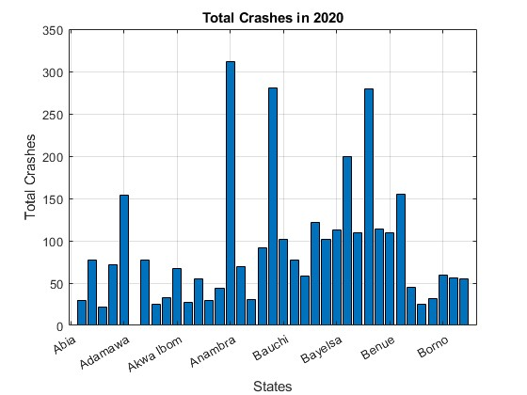

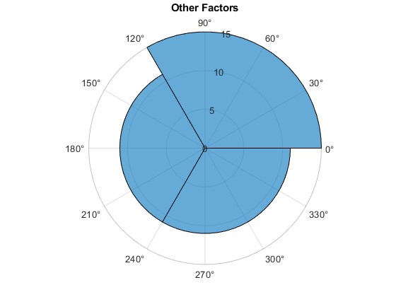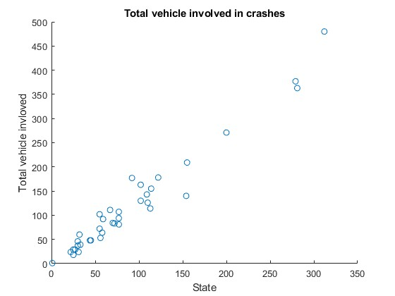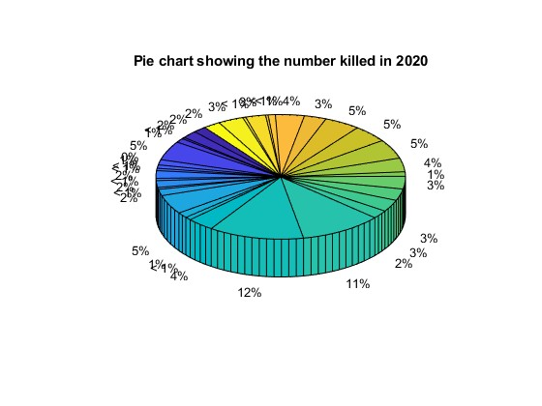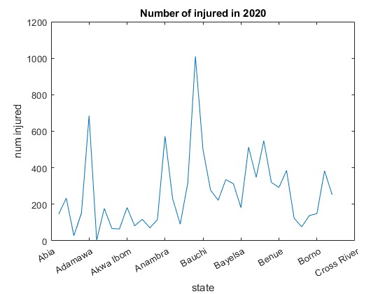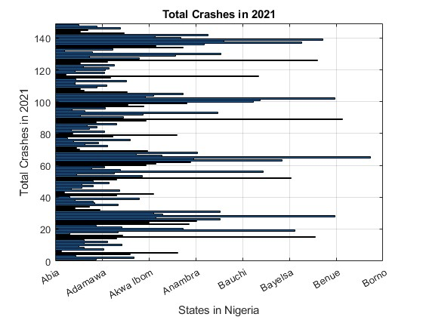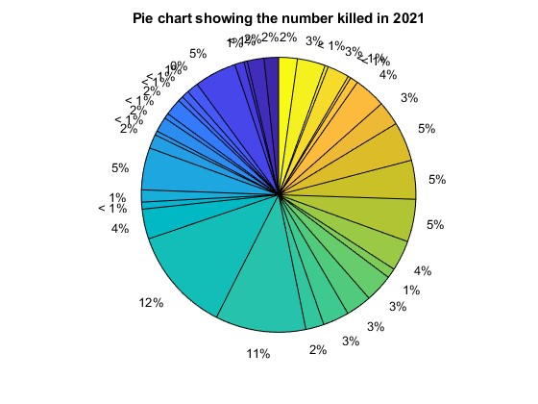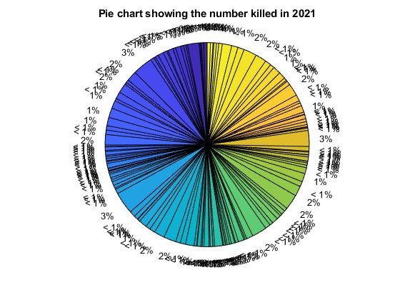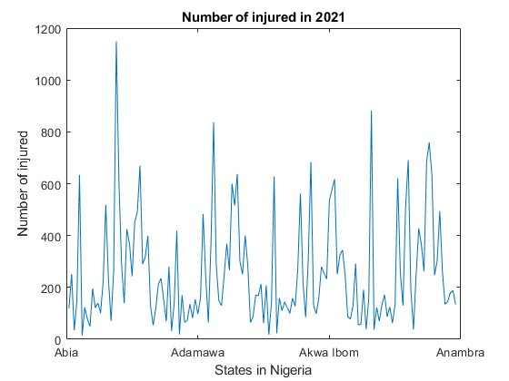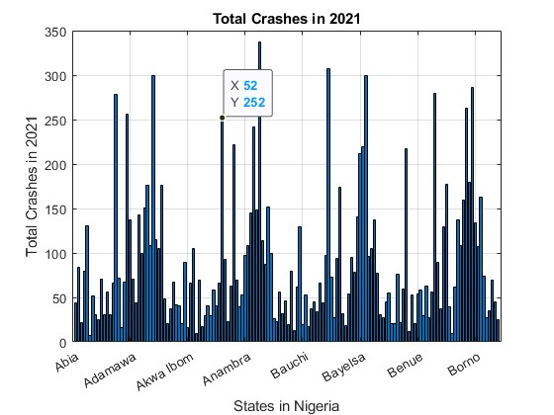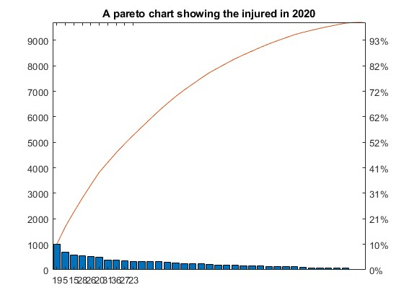

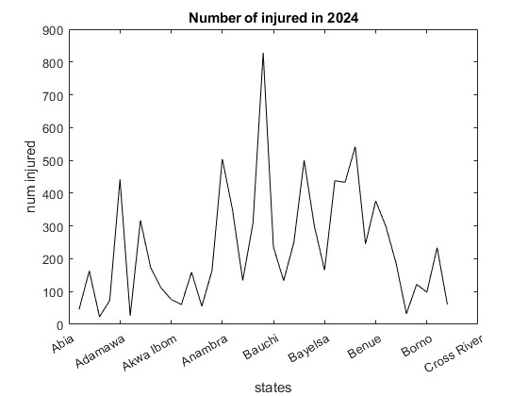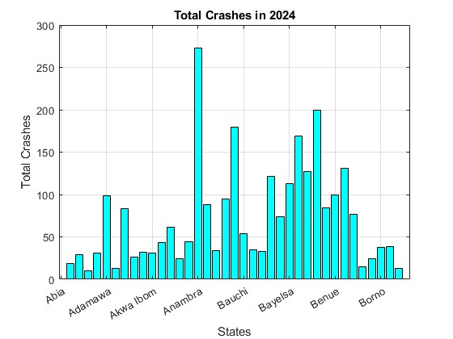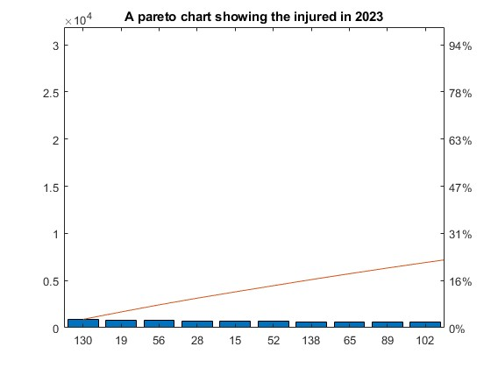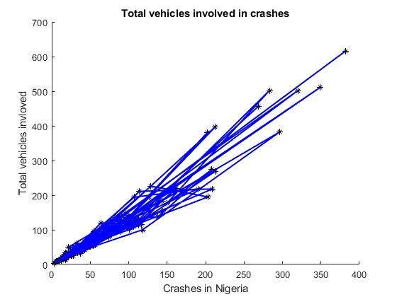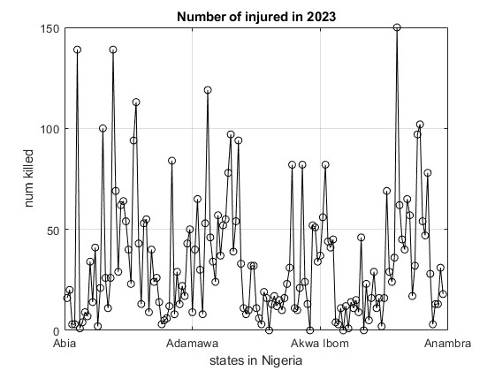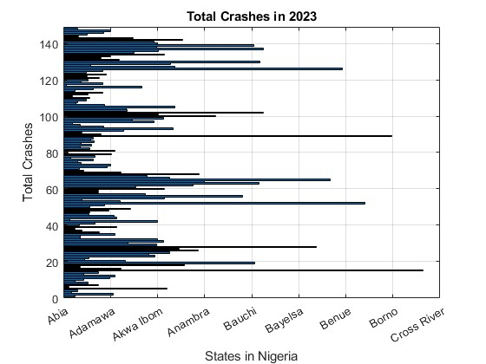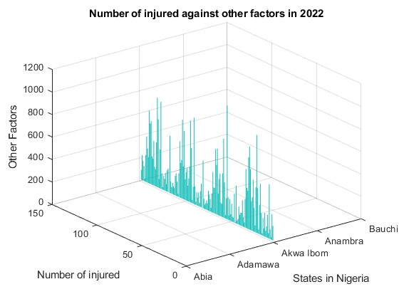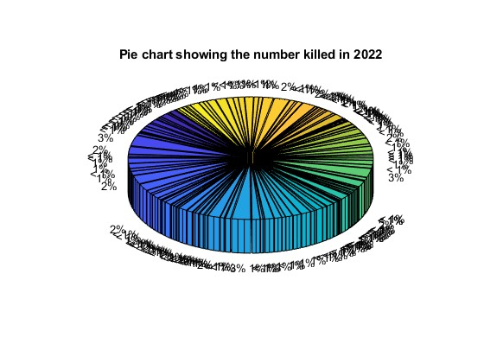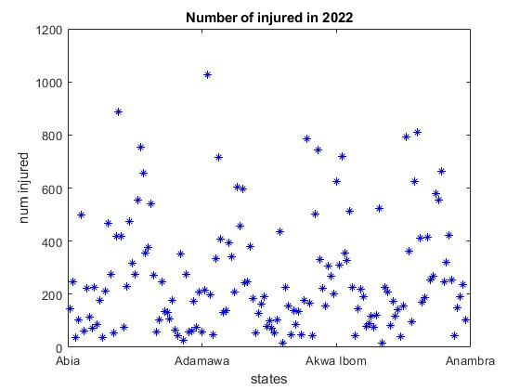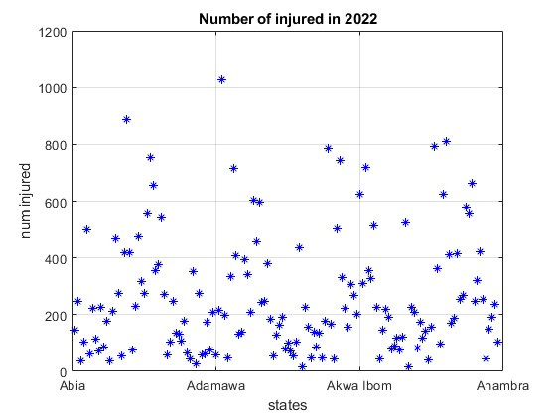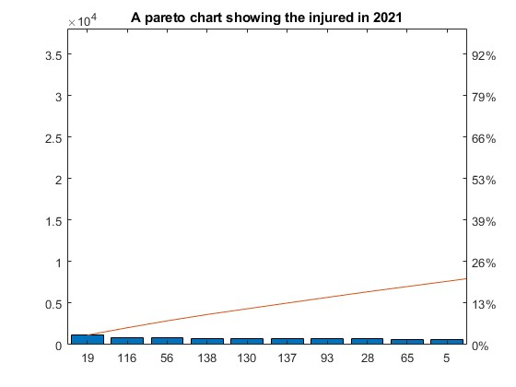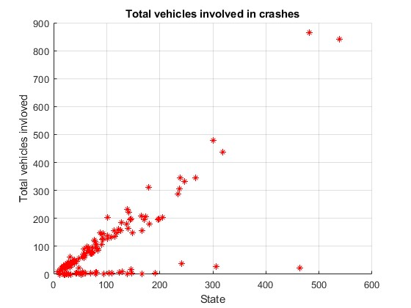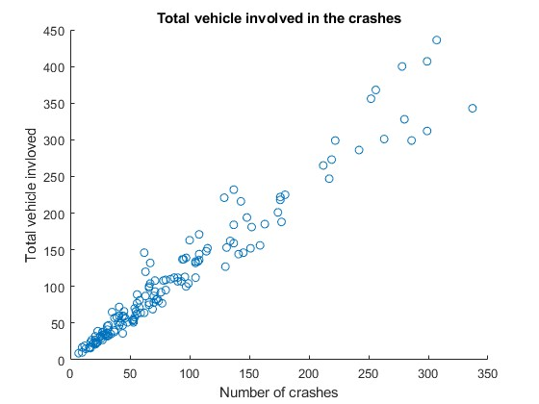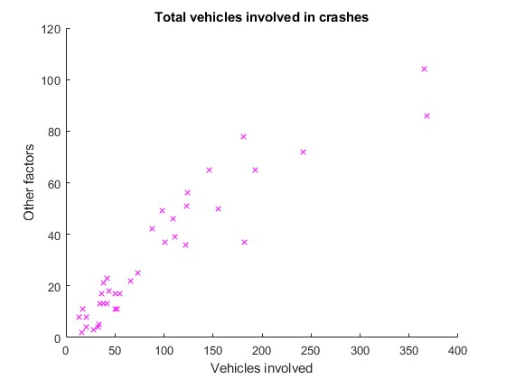

## ASSIGNMENT TWO PART (B)

* Here we managed to utilize all the knowledge we learnt from module 1 to 4 to describe the different statistical characteristics in our data and to visualize them. And also to ensure that the different attributes or data collected per individual is detailed enough to describe them.
* The first line;
* members=struct('name',{},'age',{},'religion',{},'village',{},'facialrepresentation',{},'course',{},'interests',{},'tribes',{});
* It defines the fields (or properties) that each element in the members array will have: ‘name’ , ‘age’ , ‘religion’ , ‘village’ , ‘facialrepresentation’ , ‘course’ , ‘interests’ and ‘tribes’.
* The empty curly brackets {} indicate that these fields are initially empty cell arrays, ready to hold data of various.

%members(1)

members(1).name=('chelimo sandra');

members(1).age=('30');

members(1).religion=('anglican');

members(1).village=('taragon');

members(1).facialrepresentation=imread('ngc6543a.jpg');

members(1).course=('war');

members(1).interests=('food');

members(1).tribes=('sabiny');

EXTRUCT INTO ARRAYS

* This matlab code snippet i designed to extract specific ields from a structure array named members and store them into indivudual cell arrays or numeric arrays’

%% ---Descriptive Statistics---

fprintf('===== Descriptive Statistics =====');

fprintf('Number of Members: %d\n', numel(members));

fprintf('Mean Age: %.2f\n', mean(ages));

fprintf('Median Age: %.2f\n', median(ages));

fprintf('Maximum Age: %d\n', max(ages));

fprintf('Minimun Age: %d\n', min(ages));

fprintf('Age Range: %d\n', max(ages)-min(ages));

fprintf('Standard Deviation of Ages: %2f\n\n', std(ages));

* This code is highly useful for data organization and manipulation in MATLAB, particularly when dealing with specific data types.

### THE ENTIRE CODE

%%designing to struct

members=struct('name',{},'age',{},'religion',{},'village',{},'facialrepresentation',{},'course',{},'interests',{},'tribes',{});

%members(1)

members(1).name=('chelimo sandra');

members(1).age=('30');

members(1).religion=('anglican');

members(1).village=('taragon');

members(1).facialrepresentation=imread('ngc6543a.jpg');

members(1).course=('war');

members(1).interests=('food');

members(1).tribes=('sabiny');

%members(2)

members(2).name=('muhangi mouris');

members(2).age=('25');

members(2).religion=('pentecostal');

members(2).village=('kampala');

members(2).facialrepresentation=imread('ngc6543a.jpg');

members(2).course=('meb');

members(2).interests=('prayer');

members(2).tribes=('munyankole');

%members(3)

members(3).name = 'econi ronald';

members(3).age = '24';

members(3).religion = 'anglican';

members(3).village = 'drandrua';

members(3).course = 'ami';

members(3).interests = 'dancing';

members(3).tribes = 'lugbara';

%members(4)

members(4).name = 'adongo poffia';

members(4).age = '27';

members(4).religion = 'pentecostal';

members(4).village = 'soroti';

members(4).course = 'ami';

members(4).interests = 'eating';

members(4).tribes = 'acholi';

%members(5)

members(5).name = 'obur charles';

members(5).age = '21';

members(5).religion = 'catholic';

members(5).village = 'agago';

members(5).course = 'ape';

members(5).interests = 'music';

members(5).tribes = 'acholi';

%members(6)

members(6).name = 'nakazibwe ethel';

members(6).age = '35';

members(6).religion = 'pentecostal';

members(6).village = 'kawanda';

members(6).course = 'ami';

members(6).interests = 'chess';

members(6).tribes = 'lugbara';

%member(7)

members(7).name = 'ogutu daniel wafula';

members(7).age = '21';

members(7).religion = 'anglican';

members(7).village = 'makina';

members(7).course = 'war';

members(7).interests = 'catering';

members(7).tribes = 'samia';

%member(8)

members(8).name = 'owor hamidu';

members(8).age = '22';

members(8).religion = 'islam';

members(8).village = 'ntawo';

members(8).course = 'pti';

members(8).interests = 'writing';

members(8).tribes = 'mugisu';

%member(9)

members(9).name = 'onanyang francis';

members(9).age = '26';

members(9).religion = 'anglican';

members(9).village = 'kumi';

members(9).course = 'war';

members(9).interests = 'playing';

members(9).tribes = 'etesot';

%member(10)

members(10).name = 'odongo joseph';

members(10).age = '23';

members(10).religion = 'catholic';

members(10).village = 'lira';

members(10).course = 'ami';

members(10).interests = 'music';

members(10).tribes = 'langi';

%% Extract data into arrays/tables

ages = str2double({members.age});

names = {members.name};

religions = {members.religion};

villages = {members.village};

courses = {members.course};

interests = {members.interests};

tribes = {members.tribes};

%% ---Descriptive Statistics---

fprintf('===== Descriptive Statistics =====');

fprintf('Number of Members: %d\n', numel(members));

fprintf('Mean Age: %.2f\n', mean(ages));

fprintf('Median Age: %.2f\n', median(ages));

fprintf('Maximum Age: %d\n', max(ages));

fprintf('Minimun Age: %d\n', min(ages));

fprintf('Age Range: %d\n', max(ages)-min(ages));

fprintf('Standard Deviation of Ages: %2f\n\n', std(ages));

%% Frequency Summeries

religionCategories = unique(religions);

religionCounts = cellfun(@(x) sum(strcmp(religions,x)), religionCategories);

courseCategories = unique(courses);

courseCounts = cellfun(@(x) sum(strcmp(courses,x)), courseCategories);

tribeCategories = unique(tribes);

tribeCounts = cellfun(@(x) sum(strcmp(tribes,x)), tribeCategories);

villageCategories = unique(villages);

villageCounts = cellfun(@(x) sum(strcmp(villages,x)), villageCategories);

interestCategories = unique(interests);

interestCounts = cellfun(@(x) sum(strcmp(interests,x)), interestCategories);

%% visualization

% a. Histogram of Ages

figure;

histogram(ages, 'FaceColor',[0.2 0.6 0.8], 'EdgeColor','k');

xlabel('Age');

ylabel('Frequency');

title('Age Distribution of Members')

% b. Pie chart of Religions

figure;

pie(religionCounts, religionCategories);

title('Religion Distribution');

% c. Bar Charts Of Courses

figure;

bar(categorical(courseCategories), courseCounts, 'FaceColor',[0.3 0.8 0.4]);

xlabel('Course');

ylabel('Number of Members');

title('Course Distribution');

% d. Bar Chart of Tribes

figure;

bar(categorical(tribeCategories), tribeCounts, 'FaceColor',[0.9 0.4 0.5]);

xlabel('Tribe');

ylabel('Number of Members');

title('Tribe Distribution');

% e. Bar Chart of Villages

figure;

bar(categorical(villageCategories), villageCounts,'FaceColor',[0.5 0.5 0.9]);

xlabel('village');

ylabel('Number of Members');

title('Village Distribution')

% f. Cross-analysis: Age by Religion

figure;

boxplot(ages, religions);

xlabel('Religion');

ylabel('Age')

title('Age Distribution across Religions');

% g. Cross-analysis: Age by Course

figure;

boxplot(ages, courses);

xlabel('Course');

ylabel('Age');

title('Age Distribution across Courses');

### **BAR CHAT OF TRIBES**

* The MATLAB code provided is used to generate a bar chart visualizing the distribution of different tribes based on their number of members.
* Figure; this command creates a new figure window, which will house the generated bar.
* Bar(categorical(tribecategories) , tribeCounts, ‘FaceColor’ , [0.9 0.4 0.5]); this code is the command creating the bar chat
* categorical(tribecategories); converts the tribecategories into categorical array. This is suitable for plotting discrete categories on x-axis.
* tribeCounts: this likely represents a numerical array containing the count or number of member for each corresponding tribes.
* ‘FaceColor’ , [0.9 0.4 0.5] : This command optional argument sets the color of the bars. The RGB triplet [0.9 0.4 0.5] defines a specific shade of reddish orange.

figure;

bar(categorical(tribeCategories), tribeCounts, 'FaceColor',[0.9 0.4 0.5]);

xlabel('Tribe');

ylabel('Number of Members');

title('Tribe Distribution');

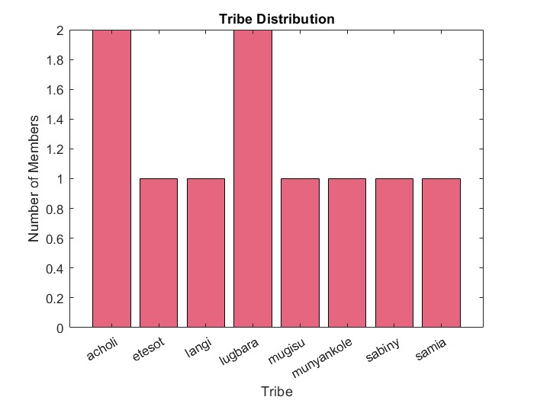

### **RELIGION DISTRIBUTION**

* The code below creates a pie chart visualizing the distribution of different religions, using religionCounts for the size of each slice and religionCategories for their labels and titles the char ‘’Religion Distribution’’

figure;

pie(religionCounts, religionCategories);

title('Religion Distribution');

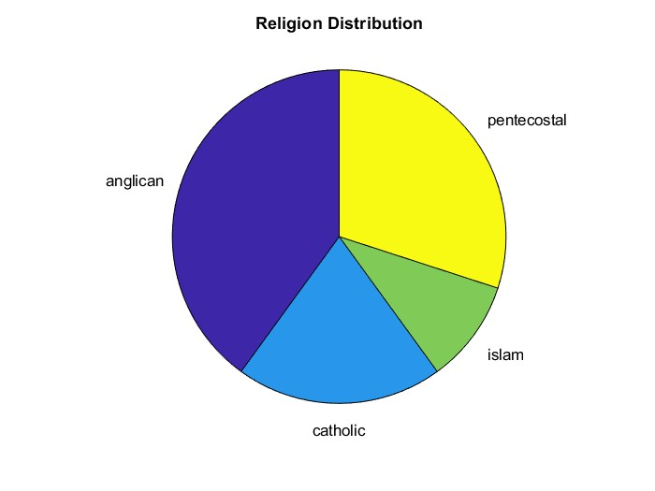

figure;

bar(categorical(courseCategories), courseCounts, 'FaceColor',[0.3 0.8 0.4]);

xlabel('Course');

ylabel('Number of Members');

title('Course Distribution');

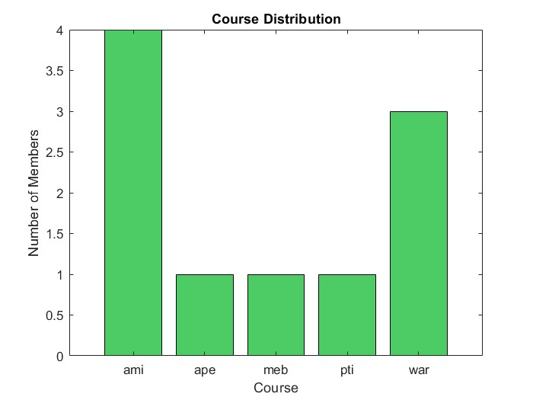

### **HISTOGRAM OF AGES**

figure;

histogram(ages, 'FaceColor',[0.2 0.6 0.8], 'EdgeColor','k');

xlabel('Age');

ylabel('Frequency');

title('Age Distribution of Members')

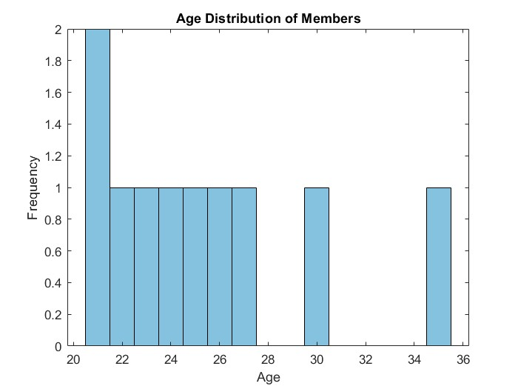

### **CROSS-ANALYSIS: AGE BY RELIGION**

figure;

boxplot(ages, religions);

xlabel('Religion');

ylabel('Age')

title('Age Distribution across Religions');

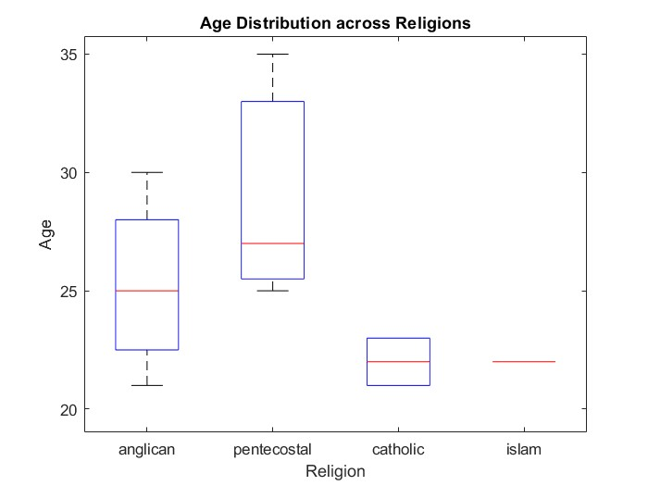

### **CROSS-ANALYSIS: AGE BY COURSE**

% g. Cross-analysis: Age by Course

figure;

boxplot(ages, courses);

xlabel('Course');

ylabel('Age');

title('Age Distribution across Courses');

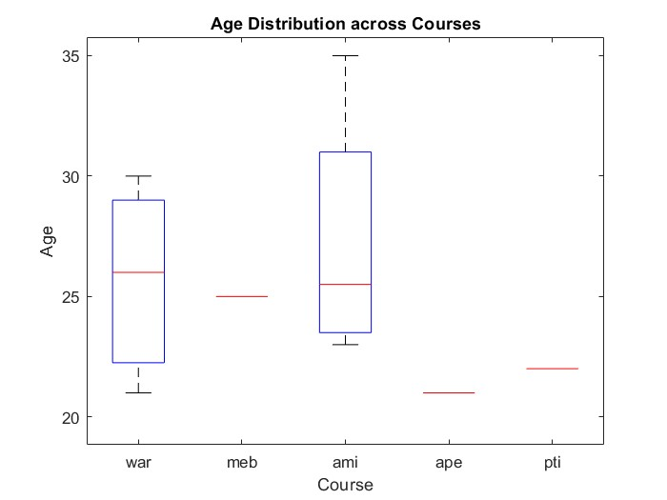

### **BAR CHAT OF VILLAGES**

figure;

bar(categorical(villageCategories), villageCounts,'FaceColor',[0.5 0.5 0.9]);

xlabel('village');

ylabel('Number of Members');

title('Village Distribution')

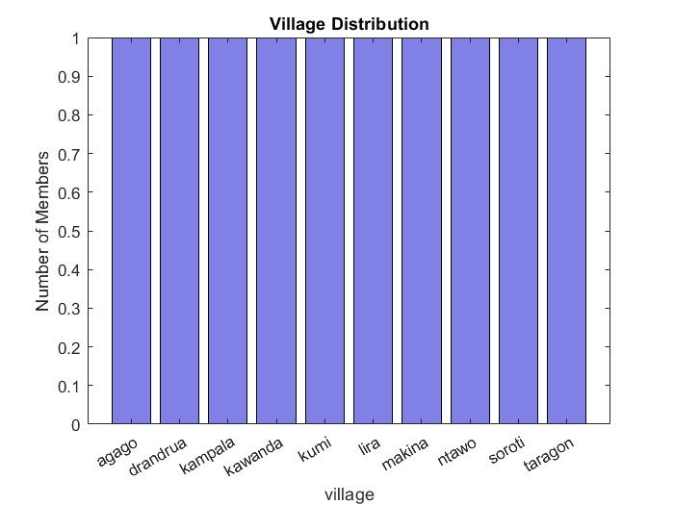

## **CONCLUSION AND LEARNING EXPERIENCE**

Completing this assignment was a valuable learning experience that reinforced key MATLAB programming concepts and gave us hands-on experience with the foundations we had acquired from Modules 1 to 3. We gained a deeper understanding of how to handle real-world data, which we realised is often messy and requires careful structuring. The process of importing from a third-party source like Kaggle, transforming the data into a more usable format like a structural array, and then exporting it cleanly highlighted a complete data workflow. The second exercise also re-enforced our knowledge of data types and the use of structural arrays in organizing heterogeneous information. The assignment as a whole provided a practical foundation in data management and problem-solving within a technical computing environment.

**References and Resources**

* [kaggle.com](https://www.kaggle.com/) - The primary source for the dataset used in this assignment.
* MATLAB Documentation - Used for syntax and function guidance on readtable(), struct(), and writetable().
* Microsoft Excel Cleaning techniques from Microsoft community forums
* You tube MATLAB tutorials